LAB221 Assignment | Type: | Short Assignment
 | Code: | J2.S.P0127
 | LOC: | 25
 | Slot(s): | 1

Title Position box color
Background Context

KeyboardEvent objects describe a user interaction with the keyboard. Each event describes a key; the event type (keydown, keypress, or keyup) identifies what kind of activity was performed. They usually use in web, and game.
Program Specifications

Design a program that allows users move a box color using arrow key

Function details:
User using arrow key to change position of box color
Expectation of User interface:

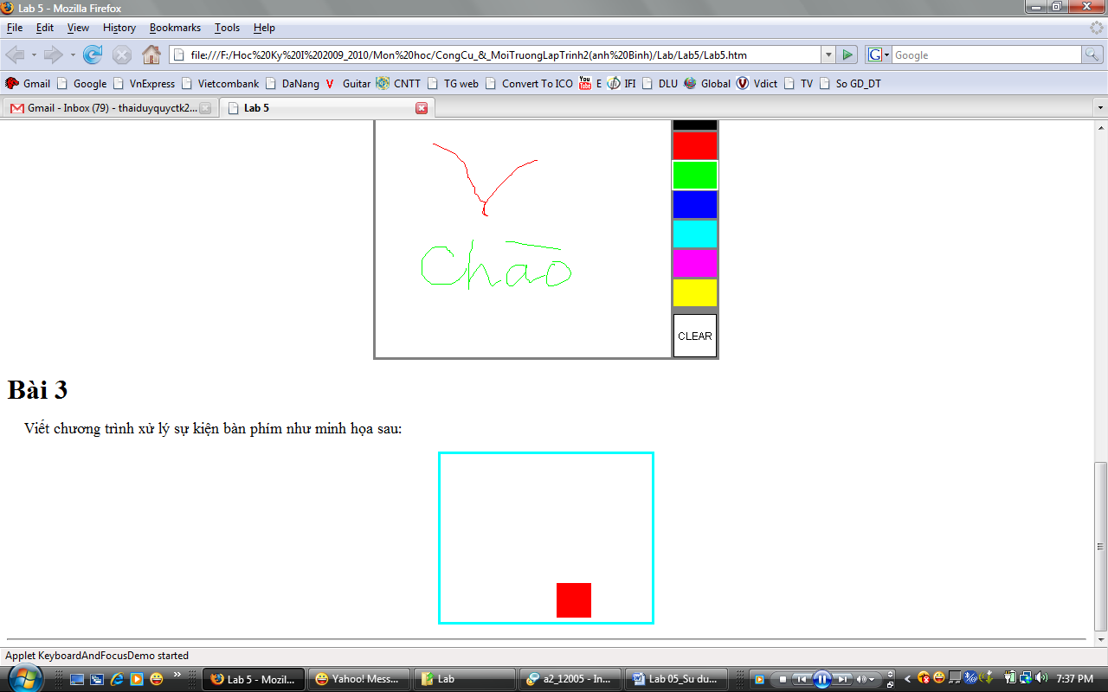

Guidelines

